What is inflation, inflation is when there is an increase in the level of prices of the goods and services. Today we are going to explain how Dwelling CPI and the rate of fuel prices affect inflation in Australia.

There are three main causes for inflation, Demands pulled – when the total demand for good and services increase the supple of goods and services, the cost pull when the cost of production goes up in which the businesses need to pass on the cost.

The Exchange rate should have a huge impact on the inflation rate, due to the exchange rate effecting the prices of services and imported goods such as Oils and raw Materials which can then increase or decrease cost of production, however looking at theattached line chart.

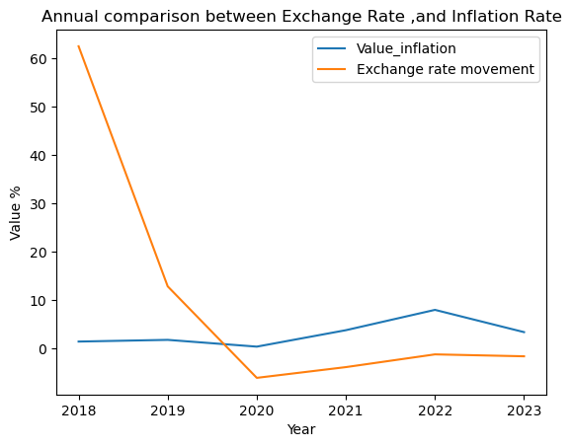between the inflation rate and the exchange rate, you can see that while 2018-2020 the exchange rate was on a decreasing trend, inflation rate didn’t move that much.

It wasn’t until 2020 when the exchange rate started to get better that the inflation rate started to rise, this could be because the pricing of goods and services had to increase to cover the loss of both during the covid pandemic which had an impact on inflation and the exchange rate due to Australia being dependant on other countries for imported goods such as fuel from Singapore which had lockdown rules implied and workers were not working and other countries were not letting ships port.

**CPI**

The best way to tell if inflation is occurring is through the Consumer Price Index (CPI) reports which is a collection of products and services and how much they have moved since the pervious quarter.

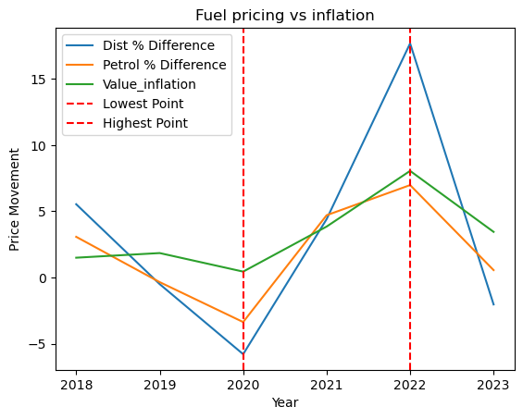

As you can see by this line graph comparing inflation and retail prices over the last five years you can see all were the lowest point during 2020 due to Covid-19 this was due to having less people on the road, less people spending money on goods and services and less people traveling due to lock down.

Following the lockdown changes and the rate that consumers were then using fuel, the pricing started to grow until 2022 when the Ukraine War started and it has been on the decline since.

Comparing this to the Inflation line you can also see that the inflation rate started to decrease as well, proving the fact that Diesel/retail pricing can have a huge impact on inflation due to it powering trucks, cars, trains, machinery, agriculture equipment which all causes the rise of production and business then need to raise the price on goods and services which can cause the Australian reserve to raise interest rates.

**Comparison between Consumer price and Wage in percentage per quarter**

**Introduction**

* Consumer Price Index, or CPI, which is a measure of the average change over time in the prices paid by urban consumers for a market basket of consumer goods and services.

**CPI Data Overview**

* Here are some key CPI data points from March 2018 to September 2023:
  + In March 2018, the CPI was 1.9%.
  + The CPI fluctuated over the years, reaching its highest point at 7.8% in December 2022.
  + In September 2023, the CPI stood at 5.4%.

**Understanding CPI Trends**

* The CPI reflects changes in the cost of living, affecting consumers' purchasing power.
* Rising CPI values indicate inflation, meaning the cost of living is increasing.
* Lower CPI values may indicate deflation or a decrease in the cost of living.

**Average Wage Overview**

* The Wage Price Index (WPI) measures changes in the price of labor over time.
* From March 2018 to September 2023, the WPI ranged from 2.0% to 4.0%.

**Analyzing CPI and Wage Trends**

* Comparing CPI and WPI trends can provide insights into economic conditions.
* When the CPI outpaces the WPI, it may indicate decreased purchasing power for workers.
* Conversely, when the WPI grows faster than the CPI, workers' purchasing power may increase.

**Conclusion**

* In conclusion, understanding the CPI and wage trends is crucial for policymakers, businesses, and individuals alike.
* By monitoring these indicators, we can better navigate economic challenges and opportunities in Australia.

**Annual comparison between CPI and average inflation in Australia**

**Introduction**

* The CPI measures changes in the cost of living, while inflation reflects the overall increase in prices for goods and services.

**CPI vs. Inflation Data Overview**

* Here are some key CPI and inflation data points from 2018 to 2023:
  + In 2018, the CPI was 1.8%, while inflation stood at 1.50%.
  + Both the CPI and inflation remained relatively stable in 2019, with the CPI at 1.8% and inflation at 1.85%.
  + In 2020, the CPI decreased to 0.9%, while inflation dropped to 0.45%.
  + The CPI surged in 2021 to 3.5%, while inflation rose slightly higher to 3.85%.
  + In 2022, both the CPI and inflation experienced significant increases, reaching 7.8% and 8.05%, respectively.
  + By 2023, the CPI decreased to 4.1%, while inflation declined to 3.45%.

**Analyzing CPI vs. Inflation Trends**

* Comparing CPI and inflation trends can provide insights into the economy's health and potential impacts on consumers.
* When the CPI exceeds inflation, it may indicate that consumer purchasing power is declining.
* Conversely, when inflation outpaces the CPI, it suggests broader price increases beyond consumer goods and services.

**Implications of CPI vs. Inflation Trends**

* Understanding CPI and inflation trends is crucial for policymakers, businesses, and individuals to make informed decisions.
* High CPI and inflation rates may lead to concerns about affordability and economic stability.
* Conversely, low CPI and inflation rates may signal economic slowdown or deflationary pressures.

**Conclusion**

* In conclusion, monitoring CPI and inflation trends is essential for assessing economic conditions and making informed decisions.
* By analyzing these indicators, we can better understand the impact on consumers and businesses in Australia.

